
ChurchLife
A publication of Congregational Church of Canton,
supporting a fellowship of Christian worshipers, and
encouraging its members to follow Jesus Christ faithfully.

Ministerial Musings 0000.doc
MINISTERIAL MUSINGS: PREPARE TO BE AMAZED

by Dr. John Tamilio III, Pastor

Welcome to spring…finally!

What a strange winter is has been. Some weeks felt were balmy. Others were frigid. Others brought blizzards and Nor’easters. What is that saying about New England weather…? It has certainly been an unpredictable season.

To some extent, this is the way that God works. God is unpredictable. Not in terms of his faithfulness, mind you. The writer of Hebrews states that “Jesus Christ is the same yesterday and today and forever” (13:8, NIV). Because Jesus is God incarnate, the same is true of the Father. God is the same “yesterday and today and forever.”

But God is unpredictable in the way that he continues to surprise us and confound our assumptions. As Rich Mullins once said, “God is a wild man.” This does not mean that God is akin to a crazed savage. It does mean, as one of my former parishioners used to say every Bible study, “God has no off-limits.” We cannot control God, try as we might. The poet Robert Burns wrote, “The best laid schemes of mice and men / Often go awry.” Maybe that’s because God shakes them up when they don’t fit his plan. The best example of this is that pivotal, sacred day on the Church calendar: Easter Sunday.

The women went to the tomb early that Sabbath morn. They brought spices to anoint the body of

Jesus. This was a Hebrew custom. Of course they expected him to be there. Why else would they have gone? Imagine their utter astonishment when they found the tomb empty! This defied their expectations, not to mention the rules of logic.

People do not rise from the dead, Lazarus notwithstanding. We look back on this event and smile. Imagine being there, though. It is no surprise that the women left the graveyard afraid, even though they were overjoyed. This doesn’t happen every day, not to mention in a lifetime!

As we approach the end of this Lenten sojourn, ask yourself how Jesus has confounded your expectations. Where are the places in your life where you thought you had everything figured out, but Christ stepped in and said, “Not so fast, my friend! Maybe you need to think about this, because this is what I am calling you to do and be.” I believe that we grow as individuals and as a faith community when we remain open to the unpredictable ways that God enters our lives and shakes things up. This may be uncomfortable, but it can also be joyous.

See you at the empty tomb.

Peace & Blessings,
Dr. John

Stewardship Update: End of MArch 2017

To keep you informed about our Pledge/Giving Status throughout the year, Resource Team will be providing regular updates in ChurchLife regarding our Stewardship status. As always, many thanks to each of you for your generous support of the Congregational Church in Canton with your time, talents and treasures! These resources provide the ways and means necessary for us to continue positively affecting people’s lives near and far in Jesus’ name. For that we are grateful, to you and to God!

For any questions about this information, or if you wish to change your pledge amount for 2017, contact Nimisha Divatia. She will then adjust your Pledge/Giving account accordingly. All pledges and giving are kept confidential.

Pledge/Giving Comparison Report: (Received 64 pledges for 2017 to date.)

Pledge/Giving Comparison Report - Information as of 03/28/2017:

2017 Amount Budgeted *2017 Amount Pledged to Date 2017 Given Year to Date

Local Expenses $145,000.00 $120,383.24 $26,319.54
Mission Outreach $15,000.00 $14,624.76 $3,696.46
Community Sr. Supper $5,000.00 $544.00 $134.00
Non-Pledge Giving xxx xxx $1,523.75
Total $155,000.00 $135,552.00 $31,673.75



We have different gifts, according to the grace given us. If a man's gift is prophesying, let him use it in proportion to his faith. If it is serving, let him serve; if it is teaching, let him teach; if it is encouraging, let him encourage; if it is contributing to the needs of others, let him give generously; if it is leadership, let him govern diligently; if it is showing mercy, let him do it cheerfully. (NIV, Romans 12:5-8)



Please keep the following people in your prayers, that they may know and receive God’s love…

In Our Church Family…
Mary (Shepter) Harnum Barbara Aron
Rev. Jean Lenk Marion Tamilio
Lillian Hinchliffe David Fleurme
Dr. Richard Levrault John Arthur

Nursing Home, Rehab & Home
Joe Remiesiewicz Warren Herman
Christina Cohen Paul R. Pinkham
Dottie Sutherland

In Our Armed Forces…
Daniel Brundage, U.S. Army
Sgt. James Miller, U.S. Army, Afghanistan
Edward Tomasello, U.S. Marines, Okinawa, Japan

2017 Church Officers & Leaders

Pastor: The Rev. Dr. John Tamilio III
Moderator: Gloria Gilson
Vice Moderator: Joseph Kendall
Clerk: Nancy Douglas
Financial Admin. Elaine MacLellan
Delegates: Cindy Tamilio

Ministry Team Leaders

Worship: Elaine MacLellan
Gloria Gilson
Christian Education:
Director: Rev. Deidre Scott
Team Leader: Nancy Worth-
Efstathiou
Resources: Jan Haughey
Outreach: Pam Loughran
Gina Franco
Fellowship: Jean Arnao
Joyce Kessler-Drews


Palm/Passion Sunday, April 9
Worship 10:00 a.m.

Maundy Thursday, April 13
Communion and Tenebrae Service 7 p.m.

Good Friday, April 14
Prayer and Reflection at 7:00 p.m.

Easter Sunday, April 16
Sunrise Service on Great Blue Hill 6:00 a.m.
(Meet in Trailside parking lot at 5:30 a.m.)

Sanctuary Easter Service 10 a.m.
Easter Egg Hunt following Service

Maundy Thursday
Communion and Tenebrae

Maundy Thursday occurs three days before Easter. On this night, we reflect upon Jesus’ Last Supper with his disciples in the Upper Room in Jerusalem. They gathered to celebrate the Jewish Passover just hours before Jesus was betrayed, tried, and crucified. The Passover is a celebration — a meal through which the Hebrew people recall their liberation from Egyptian bondage. The Last Supper, however, was anything but a celebration.

However, it was on this night that Jesus instituted the sacrament of Holy Communion. (The earliest record of this event is found in 1 Corinthians 11:23-26.) In a sense, this is a celebration. Through this meal, and the events that followed immediately afterwards, we are liberated from the bondage of sin and death.

Please join us at 7:00 pm for the Tenebrae Service on Thursday, April 13 as we recall the events of this night and share the bread and cup of the Eucharist. The solemnity of this night is one of the culminating events of Lent. It prepares us for the joy of the empty tomb.
Dr. John Tamilio III

LENT

Giving up Guilt
Rev. Greg Boyle, a Jesuit priest who ministers to high-risk youth in Los Angeles, once quipped, “I … don’t do guilt. I gave it up for Lent years ago.” Many Christians give up something for Lent but usually not guilt! Rather, Lent is seen as a time to somberly examine our sinful nature.
Having witnessed sin’s tragic effects through addiction, violence and gang warfare, Father Boyle realizes that dwelling on guilt doesn’t lead to hope or healing. Instead, he helps young people discover their God-given strengths and their ability to make life-affirming choices. His nonprofit Homeboy Industries provides positive alternatives for teenagers, who are reminded not of their guilt but of their identity as God’s beloved children.
On Good Friday Jesus conquered sin and death so we don’t have to wallow in guilt. Giving our lives to God frees us to live in the joy of forgiveness.



Sunrise Service
atop Blue Hill

As has been our tradition for many years, we will once again celebrate Easter with a Sunrise Service atop Great Blue Hill. We will gather at the Trailside Museum parking lot at 5:30 am and make our ascent up the hill for sunrise at 6:00 a.m. Please join us for this special time of worship, prayer, song, and Communion — to be followed by fellowship with coffee, donuts, and juice. For those unable to do the hike, cars can be driven to the site of our service.

So as we move through Lent toward Easter, remember despite the struggles and heartaches, that indeed “we have received from Jesus grace upon grace”. And thank Him for our many daily blessings and the gift of our church family.

Also, as the current motto reminds us, “God is still speaking.” In this period of expanded evangelism and renewal, as a congregation let us pray for wisdom and guidance in our priorities, choices and relationships, be still and listen, then to the best of our abilities, act on what God speaks to our hearts and support each other. May God’s peace be with us all as we trust and obey.



Jesus’s Seven Last Words
The Focus of Our
Good Friday Worship

When I was younger, I struggled with the term “Good Friday.” How was it good? It certainly wasn’t good for Jesus! Methodist theologian Prof. Laurence Hull Stookey reminds us that, “The crucifixion of Jesus was not some bad deal that God had to try to make the best of; it was a working out of divine intention with a view to the salvation of an otherwise doomed creation” (1996: 96).

We will gather in our chapel at 7:00 PM on Good Friday, which falls on April 14 this year, to recall the events of that day over two millennia ago. We will recite the seven last words (or sayings) of Christ — the record of what he said when he was on the cross — and reflect upon their meanings.

Dr. John Tamilio III


There will be an Easter Egg Hunt
on our church grounds
following
10 am Worship on Easter Sunday
Please contact Rev. Dee if you can help.




HAM AND BEAN DINNER
& TALENT SHOW
SATURDAY EVENING, MAY 6TH
5:30 pm
Menu: ham, Boston baked beans, coleslaw, corn bread/brown bread, brownies, cookies and ice cream.

Adults $10 ~ Seniors 65+ $8 ~ Children $6 (6-12 years) ~ under 5 free ~ family of 4 $30

Tickets will be on sale Sunday, April 2nd. Sign up sheet for Talent Show in the Narthex. Cash prizes for 1st, 2nd, and 3rd place finishers in the Talent Show.

Thank you to everyone who has contributed books to this year’s Lenten Project. We have collected some new and many gently used children’s and young adult books. Finding homes for all of the donations has not been as easy as first thought. The Nazareth Child Care Center in Jamaica Plain was delighted to hear of our desire to donate to their library. However, they will only accept new hardcover books. We will be putting together a box for them. I will be getting in touch with the local Food Pantries to see if they would like donations of our gently used books. If anyone knows of others who would like a donation of books please let us know.

For Your Information

ChurchLife deadline - The deadline date for the next issue of ChurchLife is April 30th. Please consider all events for April. Bring your submissions to the Church office or email them to office@cc-cantonma.org, noting ChurchLife in the subject line.
Articles written by Dr. John are available for anyone who would like them. They are located just outside his office. Also, printed copies of Dr. John’s sermons from past weeks are available in the Narthex.
Bin Collection – During the month of April we will be collecting for Evelyn House, a homeless family shelter in Stoughton.
Chancel Flowers - If you wish to purchase fresh flowers for the chancel, please call the church office.
Lectionary – The Daily Lectionary is available through the Mass. Conference website – www.macucc.org with a search on “lectionary.” Printed copies are available at the church office.
AA Meetings – We continue to host two AA meetings each week, Monday at 7:30pm and Thursday at 8pm.

Our Church Email Addresses

pastor@cc-cantonma.org Dr. John
cedirector@cc-cantonma.org Rev. Dee
christianed@cc-cantonma.org Rev. Dee
moderator@cc-cantonma.org Gloria Gilson
office@cc-cantonma.org Patty Doyle
bookkeeper@cc-cantonma.org Nimisha Divatia
collector@cc-cantonma.org
outreachmininstry@cc-cantonma.org



“Greetings from your Fellowship Team”. We hope you will join us every Sunday after church service in Fellowship Hall for coffee, tea, cocoa, juice and a variety of yummy desserts.
We would like to thank everyone who brings in goodies for Coffee Hour, Gloria Gilson, Armstrong Henry and Ida Samuel, Betty Johnstone, Sunny Lee, Carl Lindquist, Mary Jane Odell. You bring smiles to everyone’s faces especially our wonderful children!!!.
Love, Blessings and Peace.



The Confirmation class went on retreat at the end of February. We stayed in Onset, MA at the home of Janice & George Gibbs (Mary Jane Odell’s sister and brother-in-law). The home was located right on the water with beautiful views of the Mass Maritime Academy, the Bourne bridge and the railroad bridge. We had a great experience studying together, enjoying wonderful meals and fellowship. A special thank you to Mary Jane Odell for arranging the location as well as our mentors Donna Kendall, Sue and Richard.

We will be continuing our regular monthly meetings and programs thru the school year.

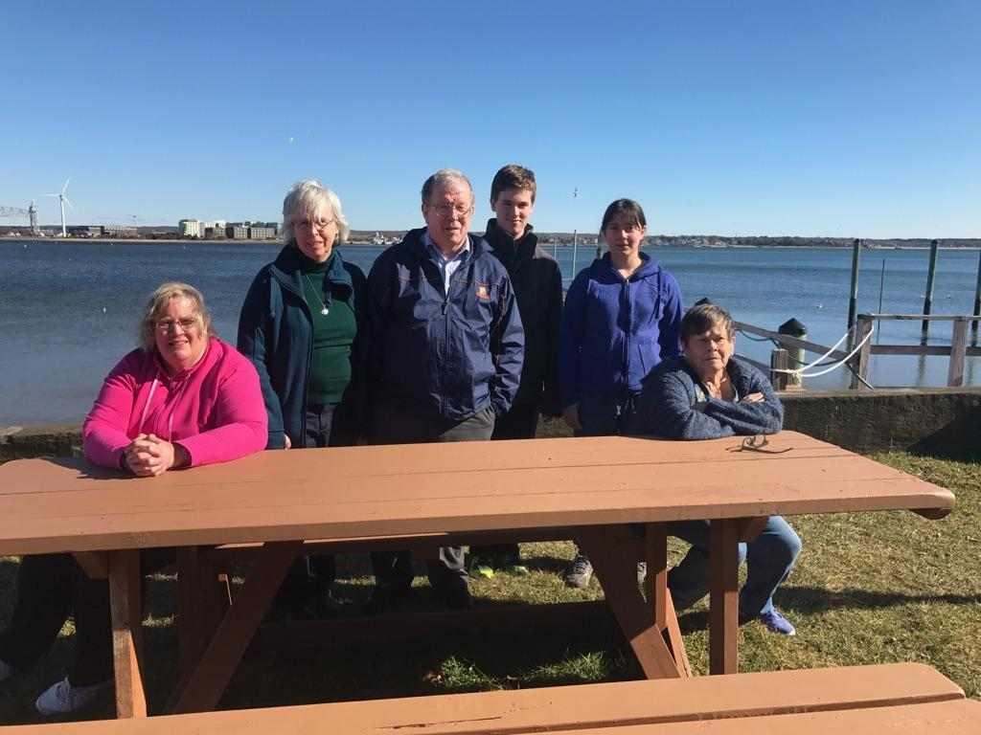





GOOD TIDINGS MINISTRY

There are some exciting happenings with the Good Tidings Ministry along with some growth pains.
We have made a connection with a family shelter program called Home Again. They have shelters in Dorchester, Roxbury and Malden. One of the areas we have been able to help is with Birthday Boxes for children in the program who are celebrating their birthday. On Friday March 24th Sandy Lindquist and Rev. Dee delivered 2 birthday boxes to Dorchester. One was for a nine year old boy and the other a twelve year old girl. One of our families here at CCC donated the box for the nine year old little boy and the staff contributed to the other box. Thank you so much for the donations.
On Sunday, Dr. John, Cindy, Jan Haughey, Sandy Lindquist and Rev. Dee brought food into the Pine Street Inn. We were informed that Pine Street was no longer accepting clothes so we brought the two car loads of clothes that we had collected over to the Goodwill Industries where they will be of help to many people in the city.
We continue to seek ways of partnering with other organizations in the South End of Boston so we can safely minister to those living on the streets.
Thank you all for your contributions of clothing, health care items, food and goodies.

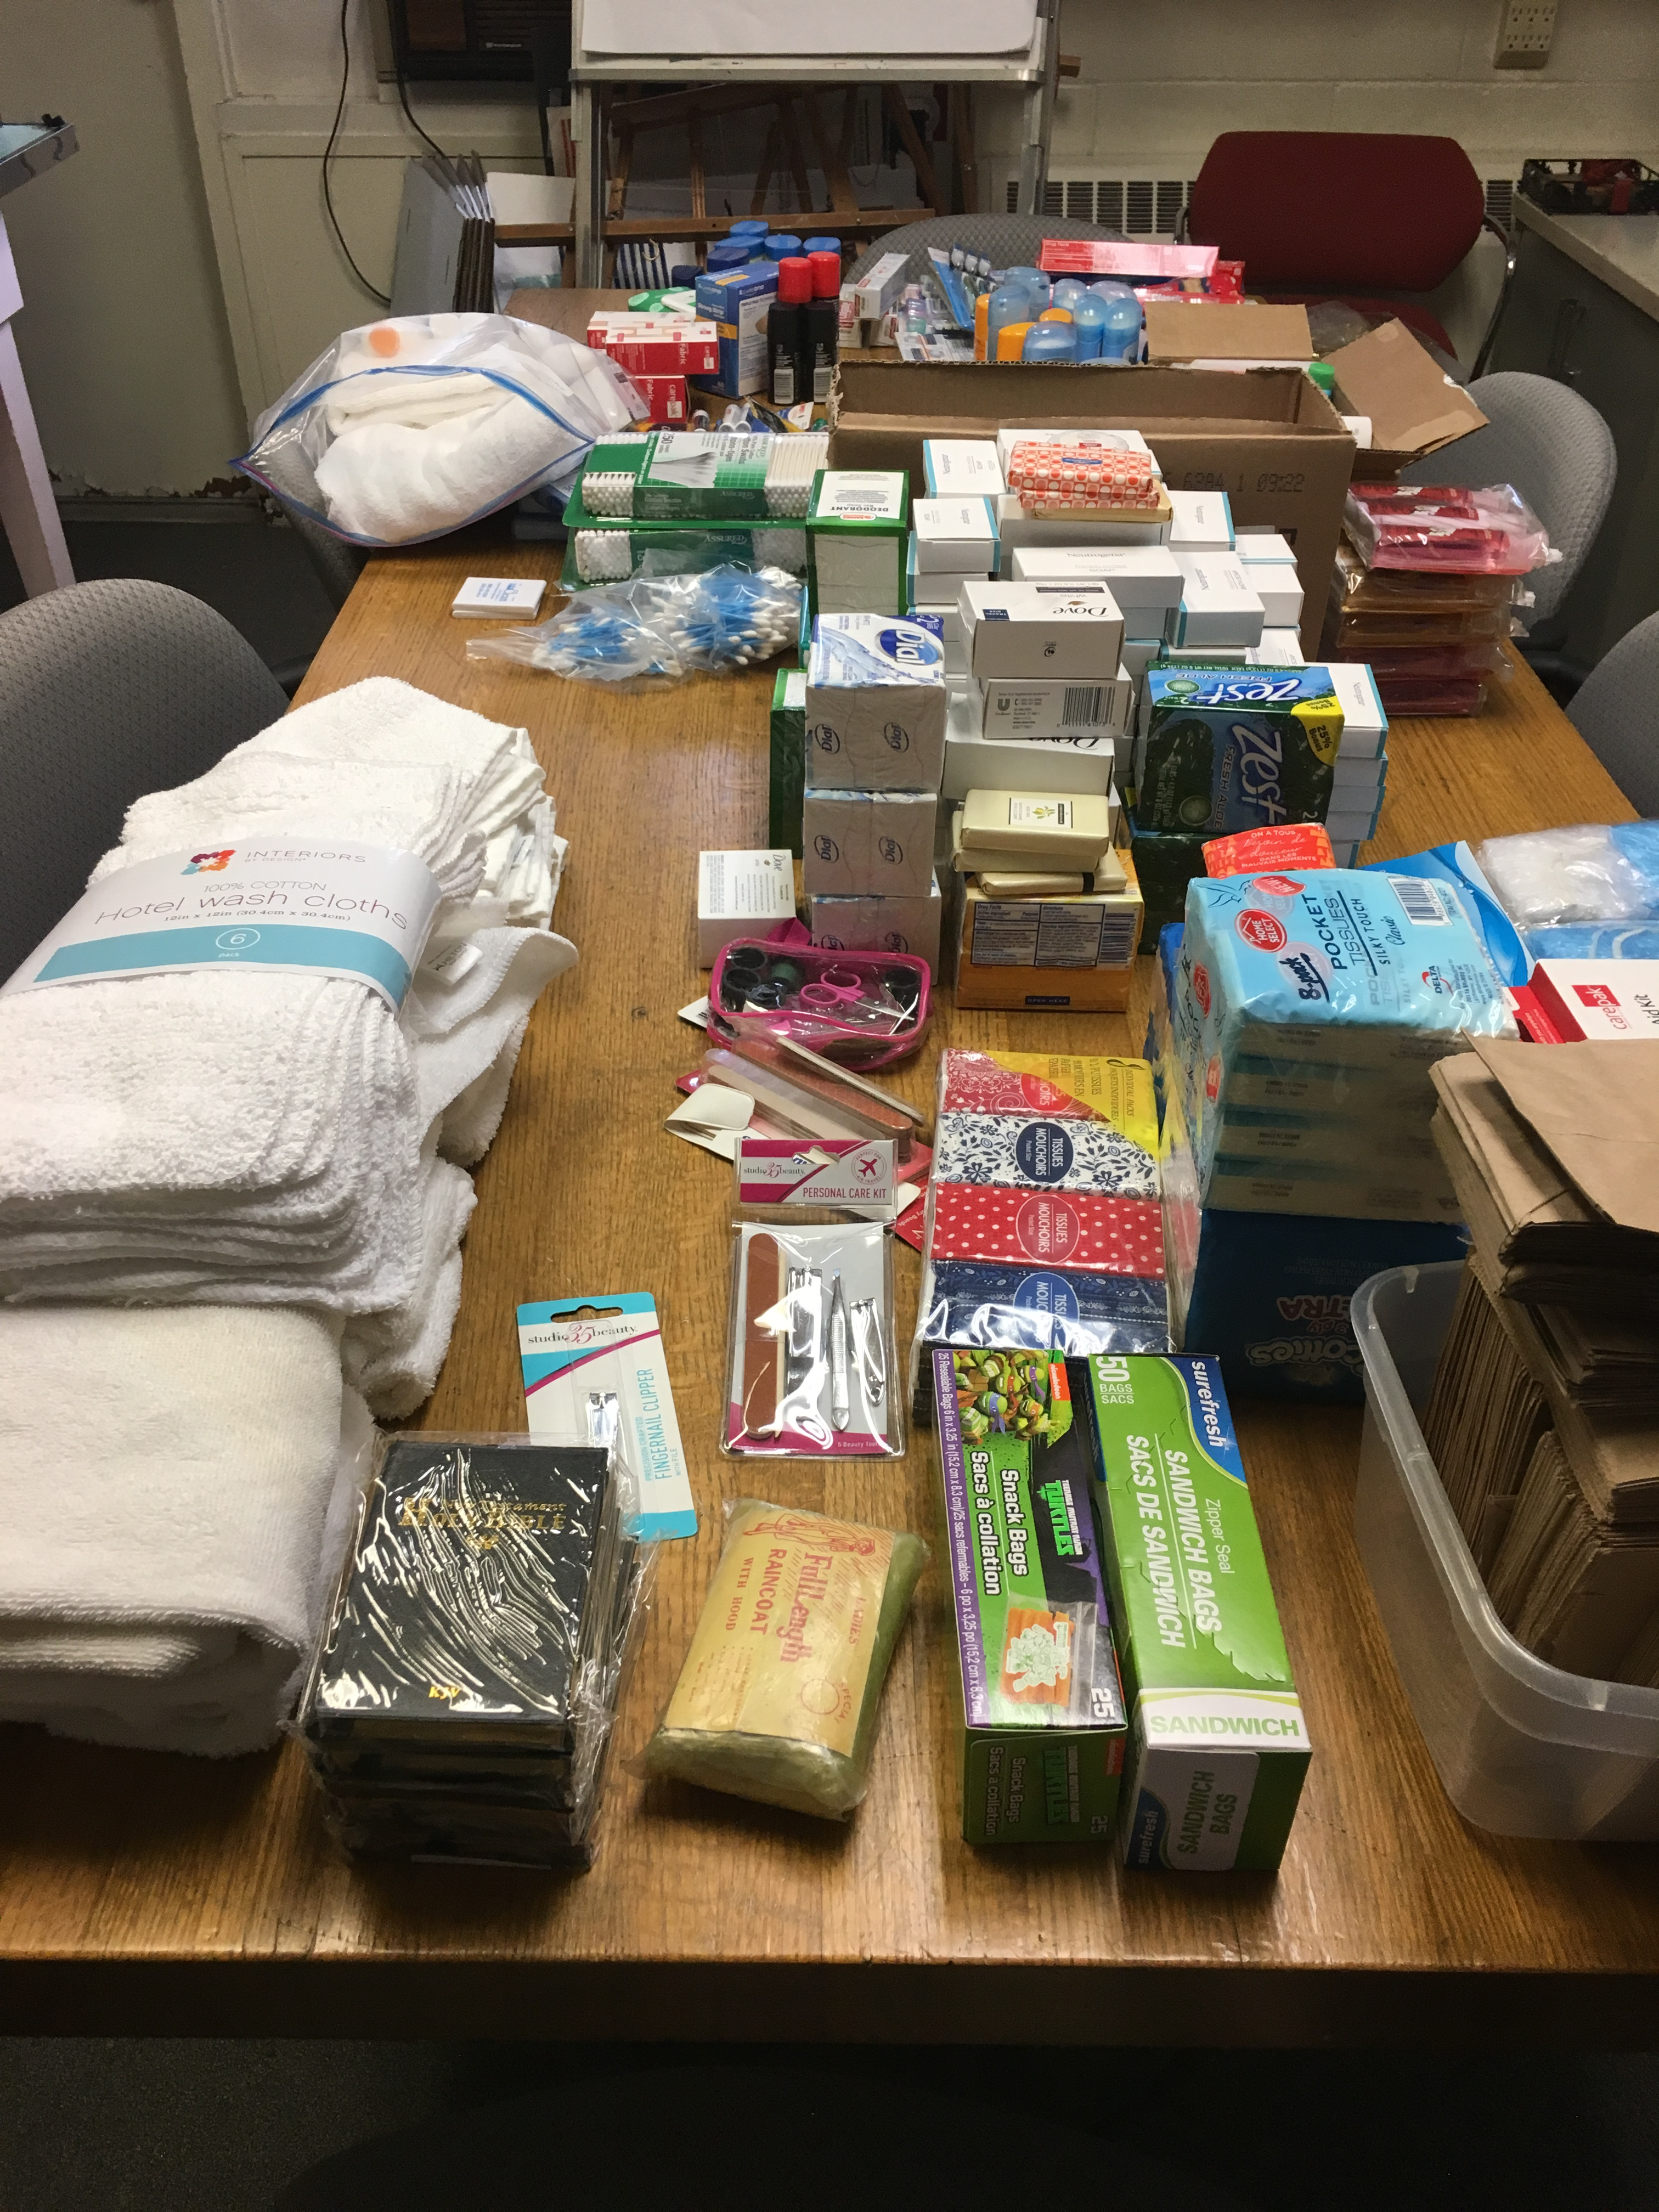



Are you ready to change how you feel about a loss in your life?

The Grief Recovery Method Support Group

The Action Program for Moving Beyond Loss

The 8-week program will take place:
Congregational Church of Canton
Mondays, April 3-May 29, 2017
From 7-9pm
(Note we will not meet wk of 4/17)

Space is limited!

The usual program fee is waived and there is a simple $25 materials fee for church members
To join us or if you have any questions or concerns, please contact:
Joe Sweeney
Certified Grief Recovery Specialist
617-388-5546
Joe@JosephSweeney.org
www.JosephSweeney.org


Wednesday, May 10th, from 7:00 – 9:00 PM we will be holding our Annual Ladies Night Out. We are looking for Vendors, Crafters or personal table consigners for that evening. The table rental fee is $35.00 plus a donation of one raffle prize item. Please contact Helen at 781-828-4524 or the church office at 781-828-2131 if you know of any vendors that may be interested in our event.



Our Lenten Bible Study group continues to meet every Thursday evening at 7:00 PM. The program will run through Thursday, April 6th. The book for this year is Simply Christian. If you are interested in participating please let us know so we can assist you in obtaining a copy of this book.



WOMEN’S BENEVOLENT UNION

Our next meeting of the Women’s Benevolent Union will be held on Wednesday, April 5th at 6:00 PM. We will have a flower arranging demonstration. Please consider coming to join in as we discuss our next missions to assist those in need.
Call 781-828-4524 to let Helen McHowell know if you are bringing a main dish, salad or dessert.

We are very grateful to everyone that contributes to our very successful monthly Senior Suppers. The amount of work that goes into purchasing and cooking for such a large group is a herculean task.
Our next supper is on Wednesday, April 19th, from 4 to 6 PM. The menu is soup or salad, baked chicken, mashed potatoes, peas and carrots, dessert, coffee and tea. The cost is $2.00 per person. Tickets are available at: Helen’s Hairstyling, Council on Aging, or in the church office.



The members and the friends, pastors and delegates of the Massachusetts Association of Congregational Christian Churches (our local association of the NACCC) continues to send their gratitude and praise for the Annual Meeting we hosted on Saturday, March 25. From the welcome, to the worship, to the food, they were overjoyed. As one of my colleagues (whose church hosted the meeting last year) said, “After seeing what you guys did, we are never hosting again!”

I want to thank everyone who participated. I especially want to thank Patty Doyle (our Administrative Assistant), Rev. Dee, and Gloria Gilson for all the behind the scenes preparatory work they did; Richard Harvey (our organist extraordinaire) for tickling the ivories in worship; and Mary Jane Odell and her kitchen crew for offering a sumptuous breakfast, lunch, and snacks. Thanks to all those who volunteered in various capacities. Your dedication is deeply appreciated.

Peace & Blessings,
Dr. John

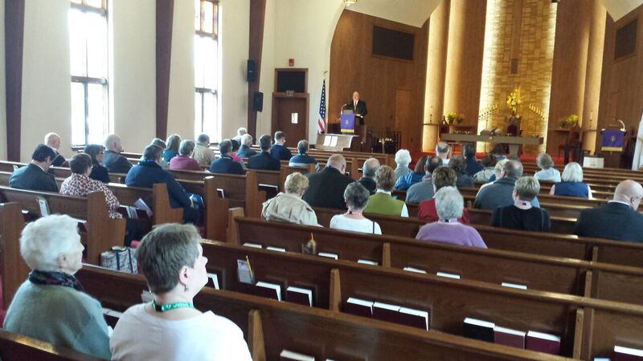

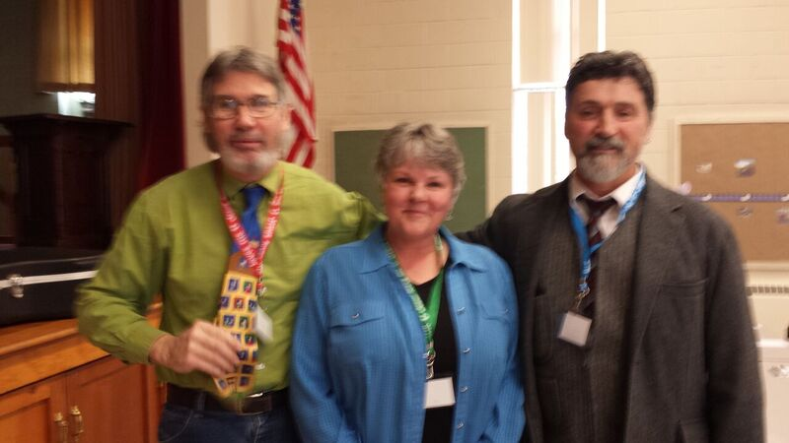

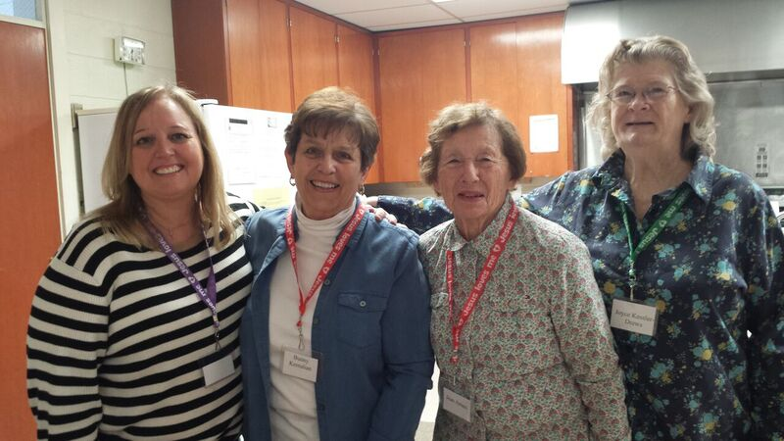

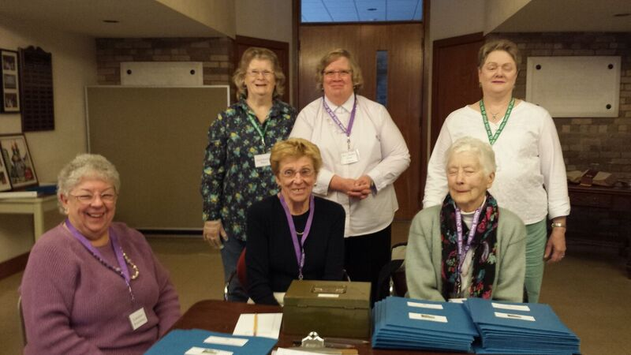



We are going to be purchasing new hymnals.
Worship & Rejoice

We would like to give everyone the opportunity of buying one in Memory Of or in Honor of someone or a group.

This information will be put on the inside cover of the Hymnal so please print clearly.

This Hymnal is given in the Memory Of:

By

Or

This Hymnal is Given in Honor Of:

By

The cost is $15.00 a hymnal. Please put on the info line of check: for new Hymnal

Checks should be made out to: Congregational Church of Canton
Attention: Elaine MacLellan
1541 Washington Street
Canton, MA 02021



Name ___________________________________________________

Please reserve ______________ Lilies at $15.00 per pot

______________Tulips at $15.00 per pot

to decorate the sanctuary for Easter. The plants are to be listed in the bulletin as

in memory of ____________________________________________________

______________________________________________________________
or

in honor of ______________________________________________________

______________________________________________________________

Please give my plant to a shut-in _______

I will take my plant ___________

Plants may be picked up after the 10 a.m. service on Easter Sunday, April 16, 2017

The deadline for ordering is Wednesday, April 5, 2017

Make your check payable to the Congregational Church of Canton
and please send with your order to the church office:

Congregational Church of Canton
1541 Washington St.
Canton MA 02021



April 2 5th Sunday in Lent Worship 10:00 AM
April 2 Deacon’s Meeting 11:00 AM
April 2 Confirmation Class movie and lunch
April 3 Grief Support Meeting 7:00 PM
April 5 WBU Pot Luck Supper 6:00 PM
April 6 Bible Study 7:00 PM
April 9 Palm Sunday Worship at 10:00 AM
April 9 Baptism during Worship
April 10 Grief Support Meeting 7:00 PM
April 13 Maundy Thursday 7:00 PM Worship
April 14 Good Friday 7:00 PM Worship
April 16 Easter Sunrise Service 6:00 AM
April 16 Easter Sunday Worship 10:00 AM
April 16 Easter Egg Hunt following Worship
April 19 Senior Supper 4:00 – 6:00 PM
April 20 Visionary Board Meeting 7:00 PM
April 23 2nd Sunday of Easter 10:00 AM Worship
April 23 Baptism during Worship
April 23 Youth Group Car Wash
April 24 Grief Support Meeting 7:00 PM
April 30 3rd Sunday of Easter 10:00 AM Worship
May 1 Grief Support Meeting 7:00 PM
May 3 WBU Meeting 6:00 PM
May 6 Ham and Bean Supper with Talent Show
May 7 4th Sunday of Easter 10:00 AM Worship
May 7 Communion Sunday
May 8 Grief Support Meeting 7:00 PM
May 9 Help Line Meeting 6:30 PM
May 10 Girl’s Night Out
May 14 5th Sunday of Easter 10:00 AM Worship
May 16 Grief Support Meeting 7:00 PM
May 17 Senior Supper 4:00 – 6:00 PM
May 21 6th Sunday of Easter 10:00 AM Worship
May 22 Grief Support Meeting 7:00 PM
May 25 Ascension of the Lord
May 28 7th Sunday of Easter 10:00 AM Worship

The Congregational Church of Canton, 1541 Washington St., Canton, MA 02021

Sunday Worship and Church School 10:00 a.m. weekly; Summer Worship 9:30 a.m. in the Chapel
Church office hours: Monday through Friday 9:00 AM – 1:00 PM. Telephone: 781-828-2131; Fax: 781-821-3451
Website: www.cc-cantonma.org Email: office@cc-cantonma.org

Canton Community Kindergarten; Director: Maria Cammarata www.cantoncommunitypreschool.com
Serves ages 2 years 9 months through 5 years. Open Monday through Friday. Telephone: 781-828-3326

ChurchLife is published for the members and friends of the Congregational Church in Canton. The purpose is to inform the church of upcoming
meetings, events and activities, and to proclaim the works of God in our midst.

Church Staff

Pastor: The Rev. Dr. John Tamilio III Office Administrator: Patty Doyle
Director of Christian Education: Rev. Deidre Scott Bookkeeper: Nimisha Divatia
Organist: Richard Harvey
Choir Director: Diane Bellissimo

The Congregational Church of Canton is part of the National Association of Congregational Christian Churches (NACCC).

Church
Life
A publication of The Congregational Church of Canton
1541 Washington Street
Canton, MA 02021



