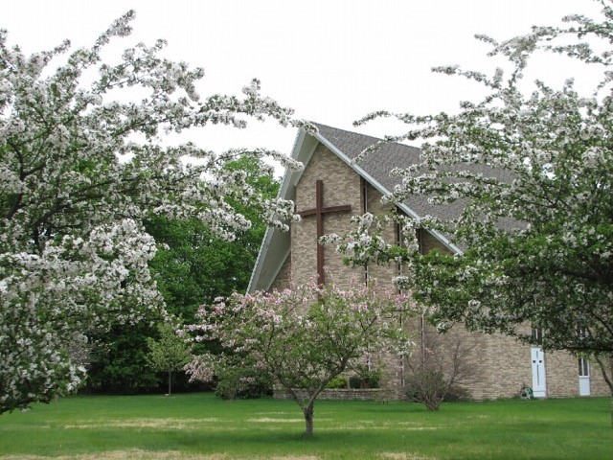
ChurchLife
A publication of Congregational Church of Canton,
supporting a fellowship of Christian worshipers, and
encouraging its members to follow Jesus Christ faithfully.

Ministerial Musings 0000.doc

MINISTERIAL MUSINGS:

by Dr. John Tamilio III, Pastor

Summer has just begun. Many of us are focused on the warm weather, vacations, and backyard barbeques. My eyes, strangely enough, are looking at the fall. This September promises to be a time of revival for us.

Actually, we are already living into this time of renewal. New faces and the new denomination we joined a year ago are all exciting signs that Jesus has blessed us.

On September 15, we are going to launch our long-awaited Capital Campaign. Based on Matthew 6:21, the campaign’s theme is “Where your treasure is, there your heart will be also.” A catered event will be held at the American Legion in Canton. Stay posted for further details. This campaign will not only fund our new roof it will also provide us with a new sign, equipment for worship, an updated fire alarm system, and a novel in-house outreach endeavor.

You will also see new bibles and hymnals in the pews. In memory of her late husband Arthur, Janice Reynolds is donating bibles for all worshippers to follow the Sunday readings. We are switching from the New Revised Standard Version (NRSV) to the new International

Version (NIV). Both translations are reputable, based on scholarly research, but the latter is a bit more readable and reflects our theological orientation.

The Music Committee has recommended Worship & Rejoice (Hope Publishing). It includes a greater variety of hymnody from the chestnuts of our faith to contemporary selections. It will augment our music ministry beyond the Pilgrim Hymnal, which has served us well. Thanks to the generosity of our members and friends – who donated hymnals in honor and memory of loved ones – this will not cost us a dime.

Other exciting projects will arise this fall. Watch for Bible studies, fundraisers, and new members joining us as we worship and serve God.

Lastly, this September will mark my five-year anniversary as your pastor. These have been the greatest five years of my ministry. Every day I thank God for bringing us together. I promise to continue to serve you faithfully in the years to come.

Wishing you Christ’s peace and blessings,
Dr. John

Stewardship Update: June 21, 2017

Each of you should give what you have decided in your heart to give,
Not reluctantly or under compulsion, for God loves a cheerful giver.
(2 Corinthians 9:7)

To keep the congregation informed about our present Stewardship status, the Resource Team has provided current details below regarding Pledges and Giving received so far for 2017. Updates will be provided throughout the year.

Don’t forget, single or repeating contributions to the church may now be made online. Just go to www.cc-cantonma.org and click on the Giving link toward the top far right. With a bank account number for Electronic Funds Transfer (EFT) or a credit card in hand; you can arrange your donation in about 5 minutes by completing a few simple steps. Please note, the fees charged to the church for donations made by Electronic Funds Transfer are significantly less than for credit card donations. Should you have any questions or would prefer assistance to set-up this process, please contact Nimisha Divatia, who is happy to help.

For questions about the information noted herein, or if at any time you wish to change your pledge amount for 2017, please direct your questions or changes to Nimisha Divatia or Elaine MacLellan. All pledges and giving are kept confidential.

Pledge/Giving Comparison Report - Information as of 06/21/2017: *(Received 63 pledges for 2017 to date.)

2017 Amount Budgeted *2017 Amount Pledged to Date 2017 Given Year to Date
Local Expenses $145,000.00 $120,639.24 $66,570.22
Mission Outreach $15,000.00 $14,624.76 $8,328.78 Community Sr. Supper $5,000.00 $544.00 $282.00
Non-Pledge Giving xxx xxx $7,961.41
Total $155,000.00 $135,808.00 $83,142.41



We have different gifts, according to the grace given us. If a man's gift is prophesying, let him use it in proportion to his faith. If it is serving, let him serve; if it is teaching, let him teach; if it is encouraging, let him encourage; if it is contributing to the needs of others, let him give generously; if it is leadership, let him govern diligently; if it is showing mercy, let him do it cheerfully. (NIV, Romans 12:5-8)



Please keep the following people in your prayers, that they may know and receive God’s love…

In Our Church Family…
Barbara Aron Reo Todesca
Rev. Jean Lenk Marion Tamilio
Lillian Hinchliffe David Fleurme

Nursing Home, Rehab & Home
Joe Remiesiewicz Warren Herman
Christina Cohen

In Our Armed Forces…
Daniel Brundage, U.S. Army
Sgt. James Miller, U.S. Army, Afghanistan

2017 Church Officers & Leaders

Pastor: The Rev. Dr. John Tamilio III
Moderator: Gloria Gilson
Vice Moderator: Joseph Kendall
Clerk: Nancy Douglas
Financial Admin. Elaine MacLellan
Delegates: Cindy Tamilio

Ministry Team Leaders

Worship: Elaine MacLellan
Gloria Gilson
Christian Education:
Director: Rev. Deidre Scott
Team Leader: Nancy Worth-
Efstathiou
Resources: Jan Haughey
Outreach: Pam Loughran
Gina Franco
Fellowship: Jean Arnao
Joyce Kessler-Drews

For Your Information

ChurchLife deadline - The deadline date for the next issue of ChurchLife is July 31st. Please consider all of the upcoming events for the fall. Bring your submissions to the Church office or email them to office@cc-cantonma.org, noting ChurchLife in the subject line.

Articles written by Dr. John are available for anyone who would like them. They are located just outside his office. Also, printed copies of Dr. John’s sermons from past weeks are available in the Narthex.

Bin Collection – During the month all of the food donations are given to the Canton Food Pantry. During the year other charities will be designated.

Chancel Flowers - If you wish to purchase fresh flowers for the chancel, please call the church office.

Lectionary – The Daily Lectionary is available through the Mass. Conference website – www.macucc.org with a search on “lectionary.” Printed copies are available at the church office.

AA Meetings – We continue to host two AA meetings each week, Monday at 7:30pm and Thursday at 8pm.

Our Church Email Addresses

pastor@cc-cantonma.org Dr. John
cedirector@cc-cantonma.org Rev. Dee
christianed@cc-cantonma.org Rev. Dee
moderator@cc-cantonma.org Gloria Gilson
office@cc-cantonma.org Patty Doyle
bookkeeper@cc-cantonma.org Nimisha Divatia
collector@cc-cantonma.org
outreachmininstry@cc-cantonma.org



On behalf of the Visionary Board I want to thank everyone who supported the Children’s Day program and Church Picnic on Sunday, June 11th.

The Board of Christian Education artfully led our children through worship with the theme of “Tell me the Stories of Jesus”. We were treated to a short drama written by our own Deborah Henry called “The Dinner Party”, which was deftly acted out by our church school students.

A very special thanks to all who assisted with the food preparation including our grill master, the Rev. Dr. John Tamilio III. May this summer season bring to all opportunities for rest and rejuvenation.

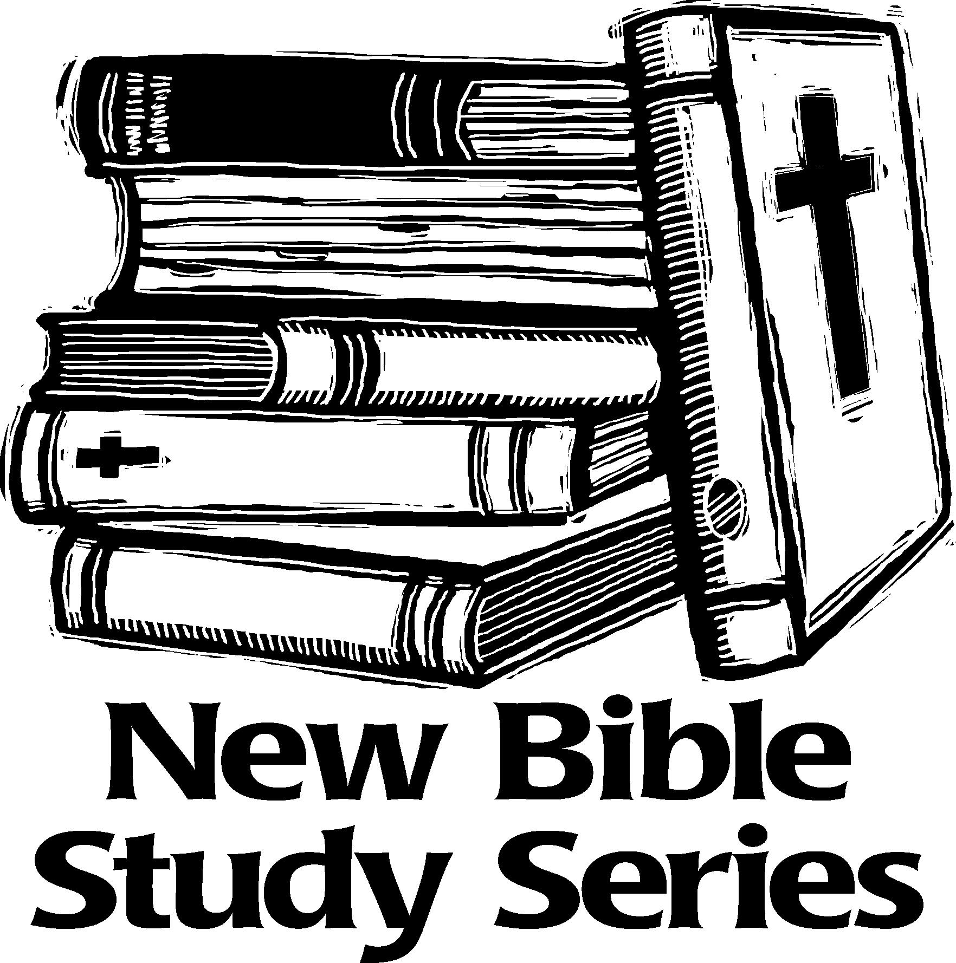

Our Lenten Bible Study group reading and discussing the book Simply Christian was very well attended and enjoyed by all. Our next series will begin in September and we hope many will consider attending.



Worship & Rejoice

We would like to thank everyone who so graciously memorialized a new hymnal. Because of your generosity we were able to purchase 325 copies. The books have been delivered and I am in the process of putting the name plates in them. We will begin using them in the fall. Elaine



The Resource Team would like to thank the following local businesses for their great service over the last few months:

Loughran Electric (swapped out old florescent fixture for new LED ones in 4 of the CCK wing rooms)

McHugo Tree Company (necessary tree clean up around the Church grounds)

Weather Shield Roofing (a new roof over Fellowship Hall)

Conway Office Solutions (new copier and service)

Partnering with these terrific local businesses has helped us keep our building and grounds safe and sound!



Church Family Apple Picking

Join us for an afternoon of apple picking at Tougas Family Farm. This is a fun way to spend a fall afternoon! More information about prices will be upcoming. Tentative date will be Sunday afternoon September 24th.



Blessing of the Animals
Sunday October 1st 2:00pm

Join us for our annual blessing of the animals service. This is a fun service where we can worship with our furry friends. Please make sure your companion animal is secure on a leash or in a carrier. A special offering is requested for local humane shelters. For the offering please consider purchasing: dog and cat food, treats, litter, pet toys, paper towels. Donations of gently used towels and blankets are always appreciated.



Rally Day and Welcome Back
Potluck Picnic ~ Sunday September 10th

Join us for the start of Church school! An exciting year is ahead for all of our children. We will be entering our second year of the Faith Weavers Now curriculum! Some of the Bible stories we will be studying this fall are Creation, Adam and Eve, Noah and the flood, and Abraham and Sara. We will continue with our music Sunday the first Sunday of each month with the children meeting in the chapel.
We encourage the children to invite friends to join us!
Families with little ones not ready yet for church school will find the nursery has had a facelift this summer. We hope it will be more welcoming for you and your little ones. Remember, you can hear the service in the nursery.
Bring along a main dish, salad, sandwiches or dessert to share for our welcome back picnic!
See you on the 10th


Celebration Bank
A special thank you to everyone who has contributed to our celebration bank this past year. This year the money that we have raised will be going to purchase some new toys for our nursery. It is our hope that during the summer we can make this room more welcoming for the families that use it each Sunday during worship.


Special Thank You to the Teachers and Assistants of our
Church School Program

Each week a dedicated group of volunteers have gathered in the Church school wing to teach and guide our children and young people as they learn about the Christian faith. On any given Sunday, you can walk by the rooms and hear songs being sung, questions asked and answered, giggles and laughs as activities are accomplished. It is a vibrant place to be! It is because of the love and dedication of the teachers we have been blessed with! Special thanks to Mary Jane Odell, Gina Franco, Donna Kendall, Nancy Worth, Carole Mac Kenzie and Susan James.
If anyone would like to join this special group of volunteers we would love to have you!



Confirmation Class and Mentor Cookout

Saturday July 15th at 4:30pm at Rev. Dee’s house (weather permitting)

Join us for a cookout and spend some time with Deb before she leaves for India



Confirmation Schedule for 2017-2018

The schedule has been set for our Confirmation classes starting in September. We will be meeting twice a month with a few additions to visit other places of worship. One weekend retreat will be scheduled early winter. The date for this will be set fairly soon and it is hoped everyone will be able to attend. A day retreat at the church will be scheduled on a Saturday in May so that the Confirmands may work on their stoles.

The first Sunday of each month will be the time that the Confirmands will meet with their mentors. They will meet for approx. an hour following worship. This time slot can have some fidget room if the mentor and Confirmand find that it is not workable on a given Sunday. They will need to reschedule their time during that month. The class will meet on the 3rd Sunday of each month. We will gather following worship for Communion with Dr. John and then have our class time. This will be a two – three-hour time period and is required for all students. Lunch will either be brought by the students (brown bag) or supplied for us by a local establishment. It is the hope of the C.E. committee that having this schedule in hand early you will be able to make necessary adjustments to the family calendars. Confirmation Sunday will be held early in June 2018.

Looking forward to seeing everyone on September 17th.


The last Senior Supper for this season was held on Wednesday June 22nd. There will be a program break during July and August.

The scheduled for the fall is:
September 20th
October 18th
November 29th

During the week of each supper, the food preparation is done after church on Sunday, with set-up for the meal on Tuesday evening. Our dedicated volunteers arrive on Wednesday sometime between 2:00pm and 5:00pm, depending on what they have volunteered to assist with.

We are very grateful to everyone that supports and contributes to these very successful monthly Senior Suppers. This ministry has grown as we reach out to our elder neighbors. The amount of work that goes into purchasing and cooking for such a large group is a herculean task that is so appreciated by all who attend.

If you have questions, would like to make a donation or volunteer to assist with this community meal please contact the office.



From Ruth Wesley

Carl Lindquist dropped by on a beautiful Easter Sunday with a lovely Lily plant from the Canton Community Congregational Church and best wishes for a happy Easter.
I missed the Church service and wonderful music by the choir, but the Lily and warm wishes brightened my day. Thank you to all for remembrance.
Sincerely, Ruth Wesley

From Rev. Peter Stevens

Dear Sandy,
Thank you for the birthday card – my 84th birthday.
It has been so kind of you to remember me for so many years, I left Canton in 1983!
As you see I have moved to Hingham now I am on my own. My two sons visit me often. David lives in Boston and Martin lives in Hanover, so I am placed in a convenient area, plus I am a few minutes’ walk to the Hingham to Boston ferry.
Say hello to anyone who remembers me in Canton.
Best wishes, Peter

Fall Schedule
August 27 Music Committee 11:15 am
September 5 Visionary Board 7:00 pm
September 7 CCK Open House 8:30 am
September 9 Yard Sale 9:00 am
September 10 Rally Day & Picnic 10:00 am
September 11 First Day of CCK
September 12 Helpline Meeting 6:30 pm
September 15/16 Capital Campaign Kick Off
September 17 Confirmation Class 11:30 am
September 20 Senior Supper 4:00 pm
September 24 Family Apple Picking
October 1 Blessing of the Animals
October 1 Confirmation Mentor Meeting
October 14 Pasta Supper
October 15 Confirmation Class 11:30 am
October 18 Senior Supper 4:00 pm
November 5 Confirmation Mentor Meeting
November 18 Church Fair
November 19 Stone Soup Sunday
November 19 Confirmation Class 11:30 am
November 29 Senior Supper 4:00 pm
December 3 Confirmation Mentor Meeting
December 17 Confirmation Class 11:30 am
December 24 Living Nativity Pageant

The Congregational Church of Canton, 1541 Washington St., Canton, MA 02021

Sunday Worship and Church School 10:00 a.m. weekly; Summer Worship in the Chapel
Church office hours: Monday through Friday 9:00 AM – 1:00 PM. Telephone: 781-828-2131; Fax: 781-821-3451
Website: www.cc-cantonma.org Email: office@cc-cantonma.org

Canton Community Kindergarten; Director: Maria Cammarata www.cantoncommunitypreschool.com
Serves ages 2 years 9 months through 5 years. Open Monday through Friday. Telephone: 781-828-3326

ChurchLife is published for the members and friends of the Congregational Church in Canton. The purpose is to inform the church of upcoming
meetings, events and activities, and to proclaim the works of God in our midst.

Church Staff

Pastor: The Rev. Dr. John Tamilio III Office Administrator: Patty Doyle
Director of Christian Education: Rev. Deidre Scott Bookkeeper: Nimisha Divatia
Organist: Richard Harvey
Choir Director: Diane Bellissimo

The Congregational Church of Canton is part of the National Association of Congregational Christian Churches (NACCC).

Church
Life
A publication of The Congregational Church of Canton
1541 Washington Street
Canton, MA 02021

